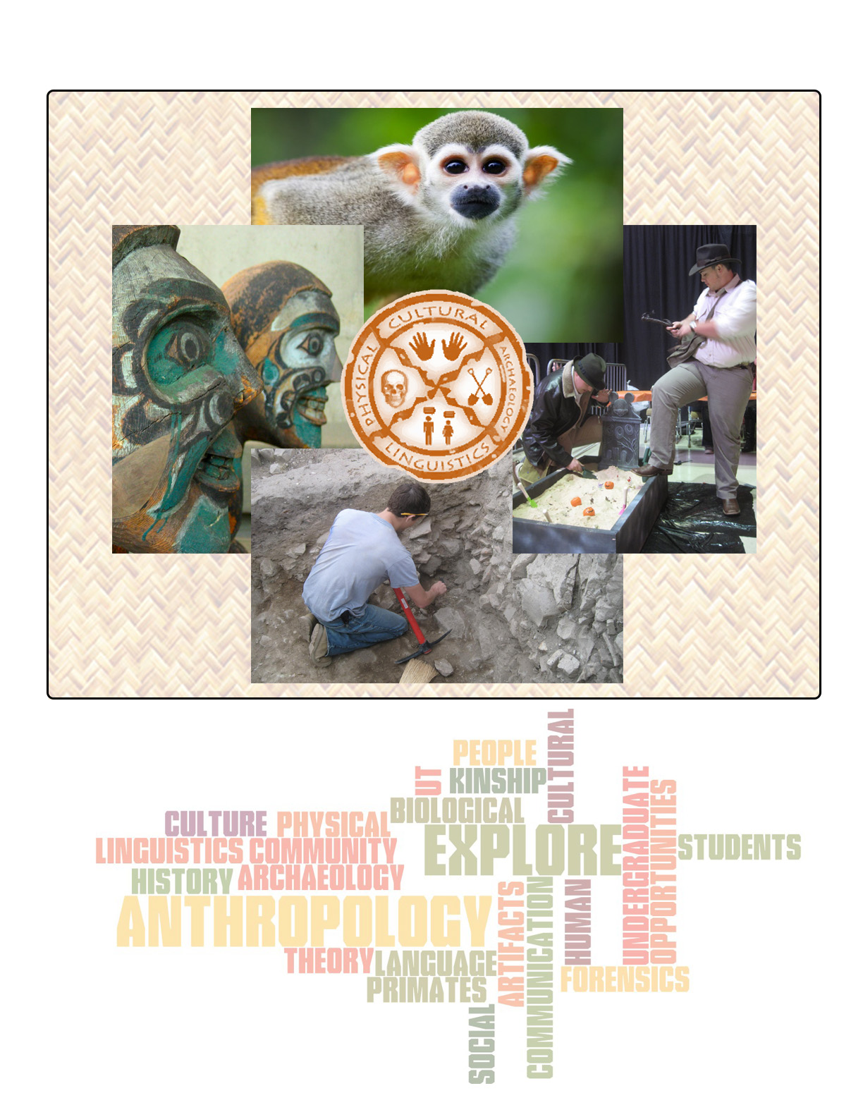
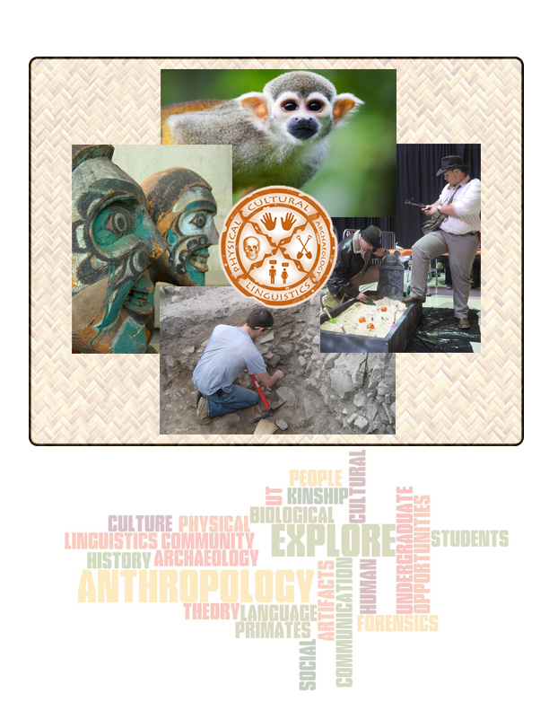
The University of Texas Anthropological Society (UTAS)

Diversity Guidance
Guest Lectures Community

We are a student organization for, though not limited to, Anthropology undergraduate students here at UT. We exist to bring together Anthropology majors (whether your focus is Cultural, Physical, Archaeological, or Linguistics) to jointly explore our own and related disciplines, become involved in the community, and learn about opportunities here at UT and elsewhere.
Meetings are fairly informal and we encourage members to suggest ideas and events for the organization. Every year we plan many events, including biweekly social nights, guest-lectures, and tours of local sites and museums. Official meetings are every other week during the fall and spring semesters, at 6 pm in room 4.174 of the Student Activity Center (SAC). Check our website calendar for the dates of meetings and upcoming events.
Visit our website at UTanthrosociety.weebly.com to learn more and to find a link to our Facebook page.

